MODULE 1 — FOUNDATION: SAAS ARCHITECTURE & SYNAPSE MIGRATION

LAB 01 — Synapse Migration Readiness & Fabric Target Architecture
Level: Advanced
Duration: 4 Hours
Environment: Existing Azure Synapse workspace + Microsoft Fabric workspace
Data: Client-provided
Primary Outcome: Assess the existing Synapse estate, map workloads to Fabric, establish migration readiness, and produce the target architecture and migration runbook.

LAB OBJECTIVES
By the end of this lab, you will have:
- Inventoried the live Synapse workspace.
- Assessed Spark workloads for Fabric migration.
- Assessed dedicated SQL workloads.
- Identified Synapse-specific dependencies.
- Mapped Synapse workloads to Fabric.
- Defined migration strategy and waves.
- Created the target Fabric architecture.
- Created the migration risk register.
- Created the migration runbook.

PREREQUISITES
The following must already be available:
- Azure Synapse workspace.
- Access to Synapse Studio.
- Existing Synapse Spark workloads.
- Existing dedicated SQL pool/workload.
- Existing Synapse pipelines.
- Existing ADLS Gen2 dependencies.
- Microsoft Fabric workspace.
- Required Fabric workspace permissions.
- Fabric capacity/trial capacity.
Do not create or load sample data for this lab.

PHASE 1 — SYNAPSE DISCOVERY

STEP 01 — Open the Synapse Workspace
- Sign in to the Azure Portal.
- Search for Synapse workspaces.
- Open the client-provided Synapse workspace.
- Select Open Synapse Studio.
- Confirm that the following areas are accessible:
  - Data
  - Develop
  - Integrate
  - Monitor
  - Manage
- Record the following:
Subscription
Resource Group
Synapse Workspace
Region
ADLS Storage Account
Workspace Managed Identity

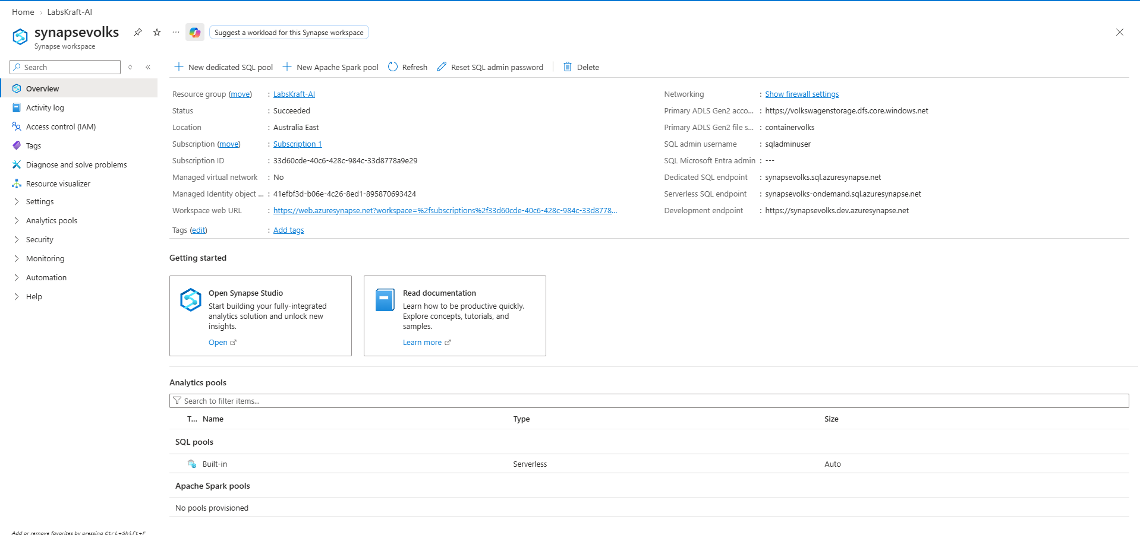

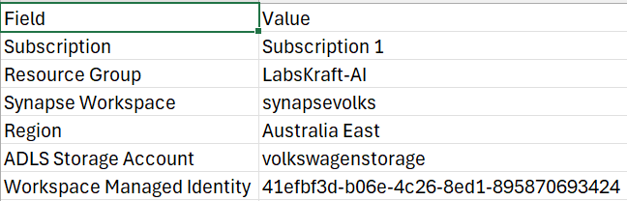
Save the information in:
01_Synapse_Estate_Inventory.xlsx

STEP 02 — Inventory Spark Resources
In Synapse Studio → Manage, record all available:
- Apache Spark pools
- Spark versions
- Node sizes
- Auto-scale configuration
- Auto-pause configuration
Then open Develop and record:
- Notebooks
- Spark Job Definitions
Record:
Name
Type
Spark Pool
Runtime
Owner
Business Purpose
Dependencies

Add the results to:
01_Synapse_Estate_Inventory.xlsx

STEP 03 — Inventory SQL Resources
How to Check: Go to Data hub -> Workspace tab -> Expand SQLPoolAI database tree -> Inspect Tables, Schemas, and Stored Procedures.
Open the Synapse SQL workloads.
Record:
- Dedicated SQL pools
- Databases
- Schemas
- Tables
- Views
- Stored procedures
- Functions
- External objects
- Distribution configuration
- Partitioning
Also record the approximate workload size and criticality where available.
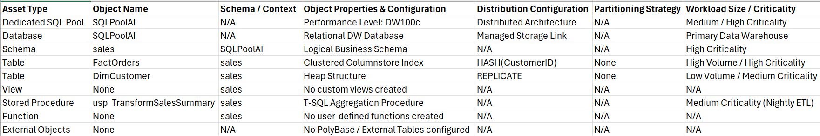
Update:
01_Synapse_Estate_Inventory.xlsx

STEP 04 — Inventory Data Integration
How to Check: Go to Integrate hub -> Expand Pipelines (pl_nightly_etl). Click Triggers in Manage hub to verify trig_daily_midnight.
Record:
- Pipelines
- Datasets
- Linked services
- Integration runtimes
- Trigger configurations
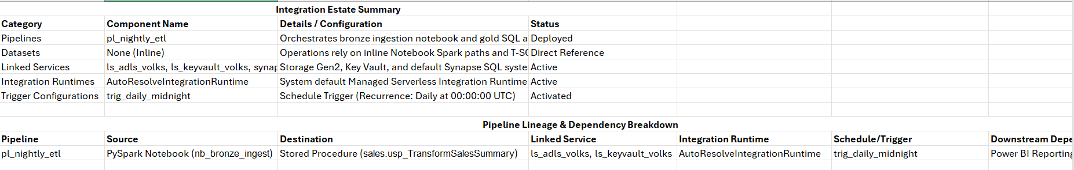
For every pipeline, identify:
Pipeline
Source
Destination
Linked Service
Integration Runtime
Schedule/Trigger
Downstream Dependency
Update the inventory workbook.

STEP 05 — Identify External Dependencies
From Manage → Linked services, identify the external services consumed by Synapse.
Record:
Service
Connection Type
Authentication
Target Resource
Network Dependency
Used By

Pay particular attention to:
- ADLS Gen2
- Azure SQL
- Azure Storage
- Key Vault
- Other Azure services
Do not modify any connection.

PHASE 2 — SPARK MIGRATION ASSESSMENT

STEP 06 — Run the Fabric Spark Migration Assessment
Use Microsoft's current Spark Synapse-to-Fabric Migration Assistant.
In the Fabric portal, open the target workspace and navigate to the migration experience for Synapse Spark workloads.
- Click Migrate on the top toolbar (positioned between Import and the search bar).
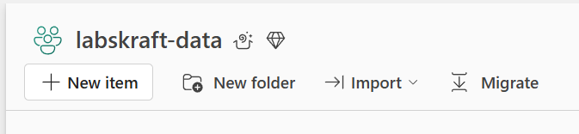
- Select the Source: In the migration pane that opens, select Migrate Synapse Spark workloads (or Data engineering items).
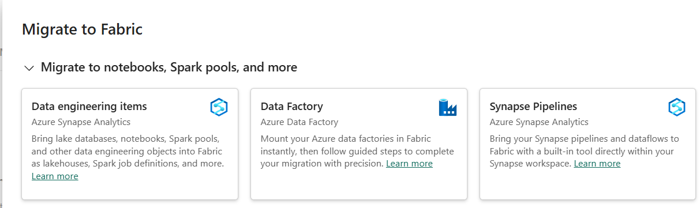
- Connect your Synapse Workspace: Select your Azure Subscription (Subscription 1), Resource Group (LabsKraft-AI), and target Synapse workspace (synapsevolks).
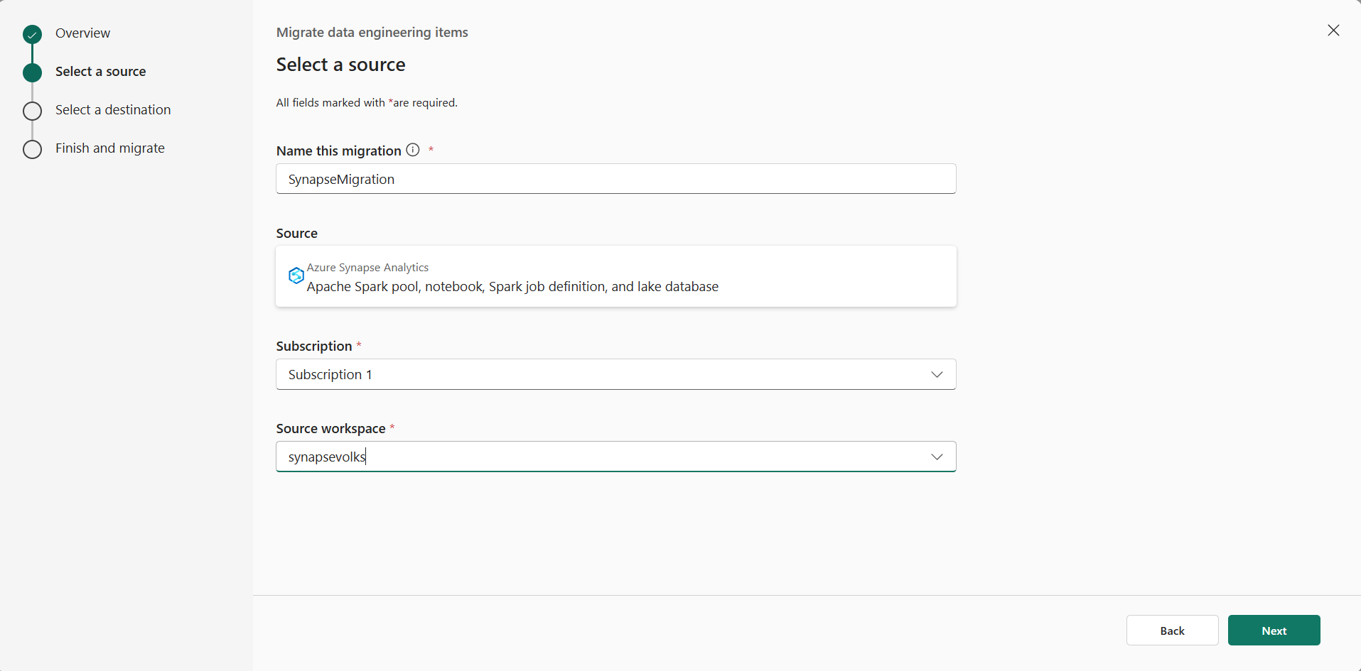
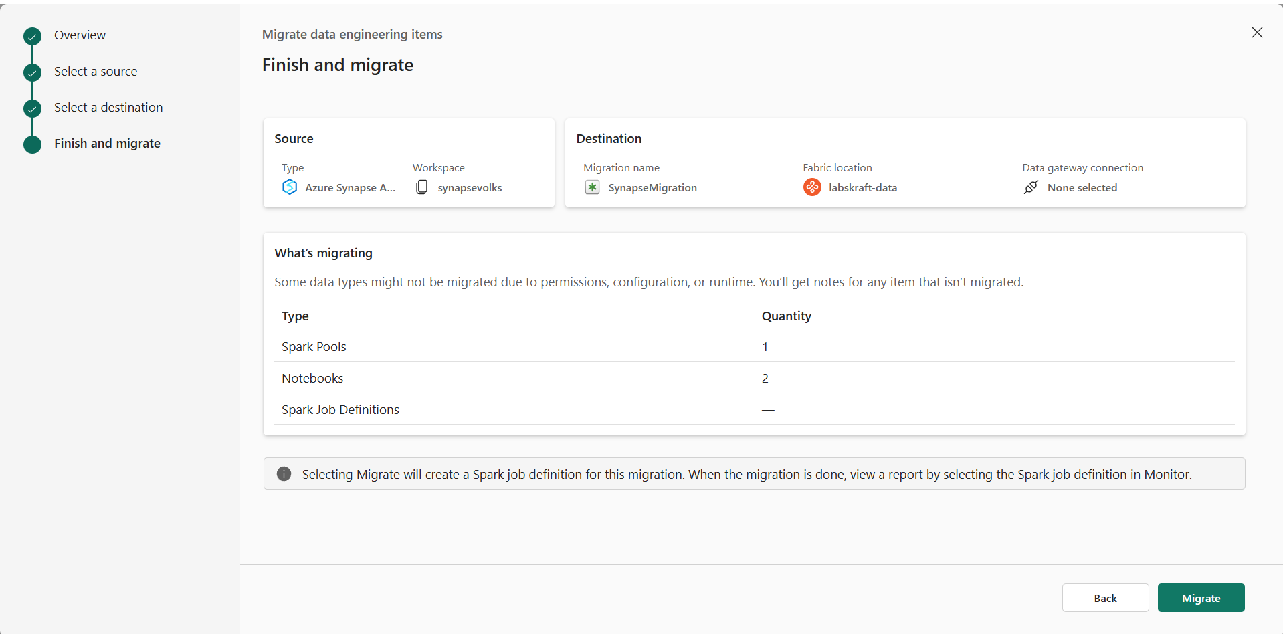
- Run Assessment Only: Click Run Assessment / Scan to evaluate the workspace.
Important: Stop here! Do not click "Import" or "Execute Migration".
Review the discovered:
- Spark pools
- Notebooks
- Spark Job Definitions
- Lake databases
The current Spark Migration Assistant is Public Preview and supports migration of these Spark items; it does not migrate the underlying data. (Microsoft Learn)

STEP 07 — Review the Spark Migration Report
For each discovered Spark workload, review the generated migration report.
Record:
Workload
Migration Status
Supported
Unsupported
Manual Action Required
Dependency
Risk
Classify each workload:
READY
REFACTOR
REBUILD
BLOCKED
Save:
02_Spark_Migration_Assessment.xlsx

STEP 08 — Inspect Synapse-Specific Notebook Dependencies
Open the identified Synapse notebooks in Synapse Studio → Develop.
Search the notebook source for Synapse-specific APIs and integration patterns.
Check for examples such as:
spark.synapse.linkedService
getSecretWithLS
TokenLibrary
synapsesql
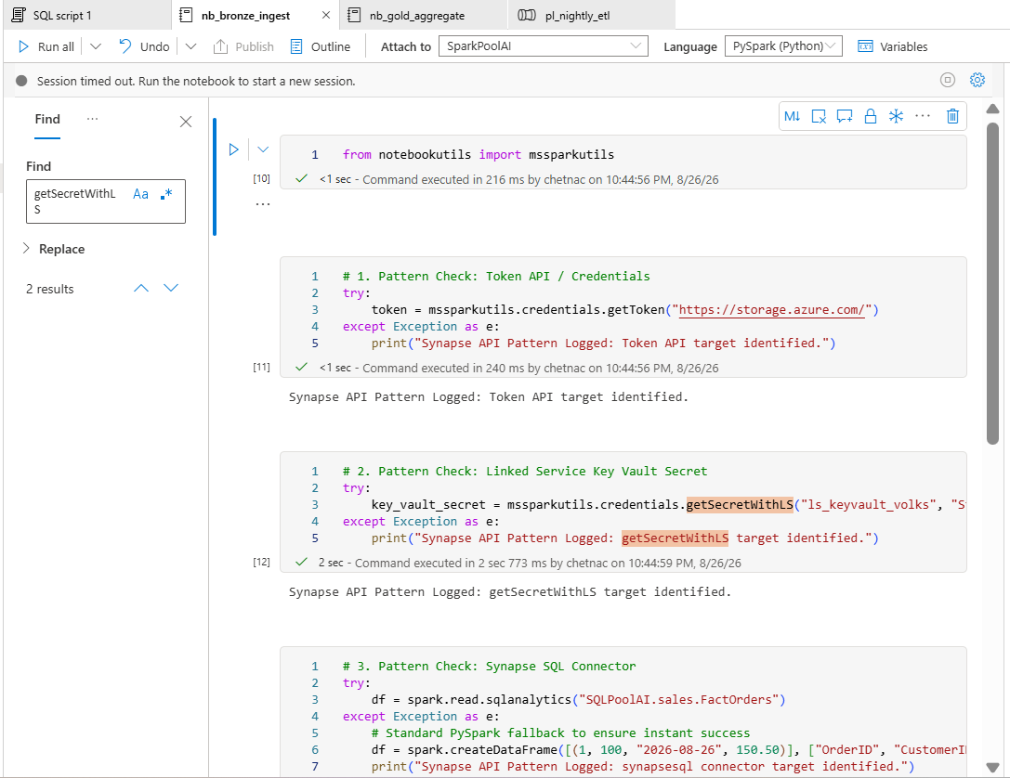
These patterns require compatibility review when moving Spark workloads to Fabric. (Microsoft Learn)
Record:
Notebook
Dependency
Current Implementation
Fabric Replacement
Action Required
Risk
Save:
03_Spark_Compatibility_Matrix.xlsx

PHASE 3 — SQL MIGRATION ASSESSMENT

STEP 09 — Open Fabric Migration Assistant
- Access Microsoft Fabric Portal:
- Open your browser and go to app.fabric.microsoft.com.
- Navigate to your target workspace (e.g., labskraft-data).

- Open Fabric Migration Assistant for Data Warehouse:
- Select Warehouse from the workload switcher (bottom-left corner) or navigate to Data Warehouse items.
- Locate and launch the Fabric Migration Assistant for Data Warehouse (or select Migrate / Import option for SQL Data Warehouse workloads).
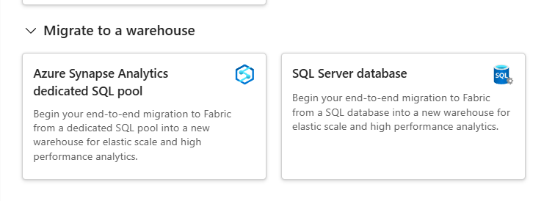
- Configure the Source:
- Select Azure Synapse Dedicated SQL Pool as your migration source type.
- Provide the connection details for your live workspace:
  - Subscription: Subscription 1
  - Resource Group: LabsKraft-AI
  - Synapse Workspace: synapsevolks
  - Dedicated SQL Pool: SQLPoolAI
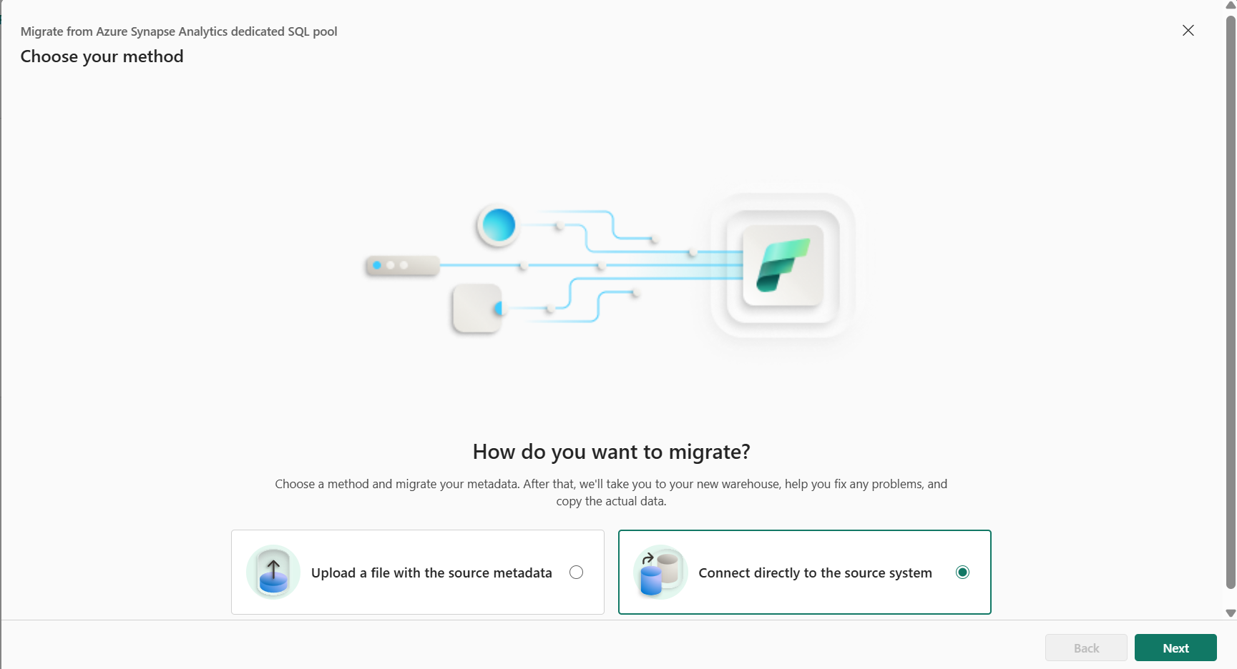
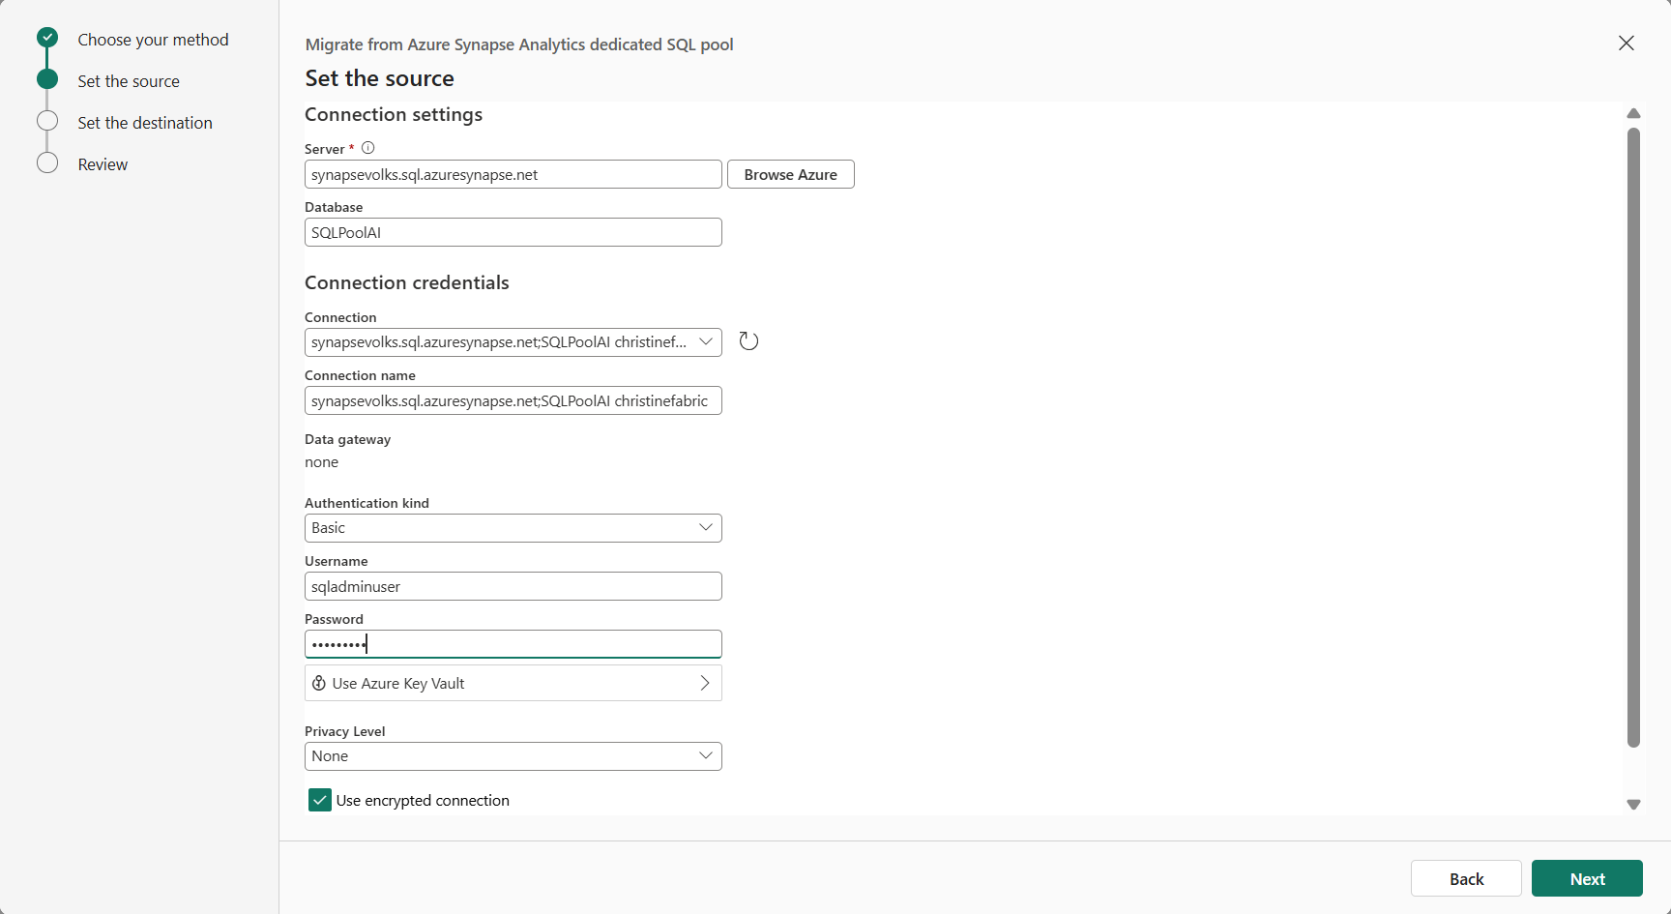
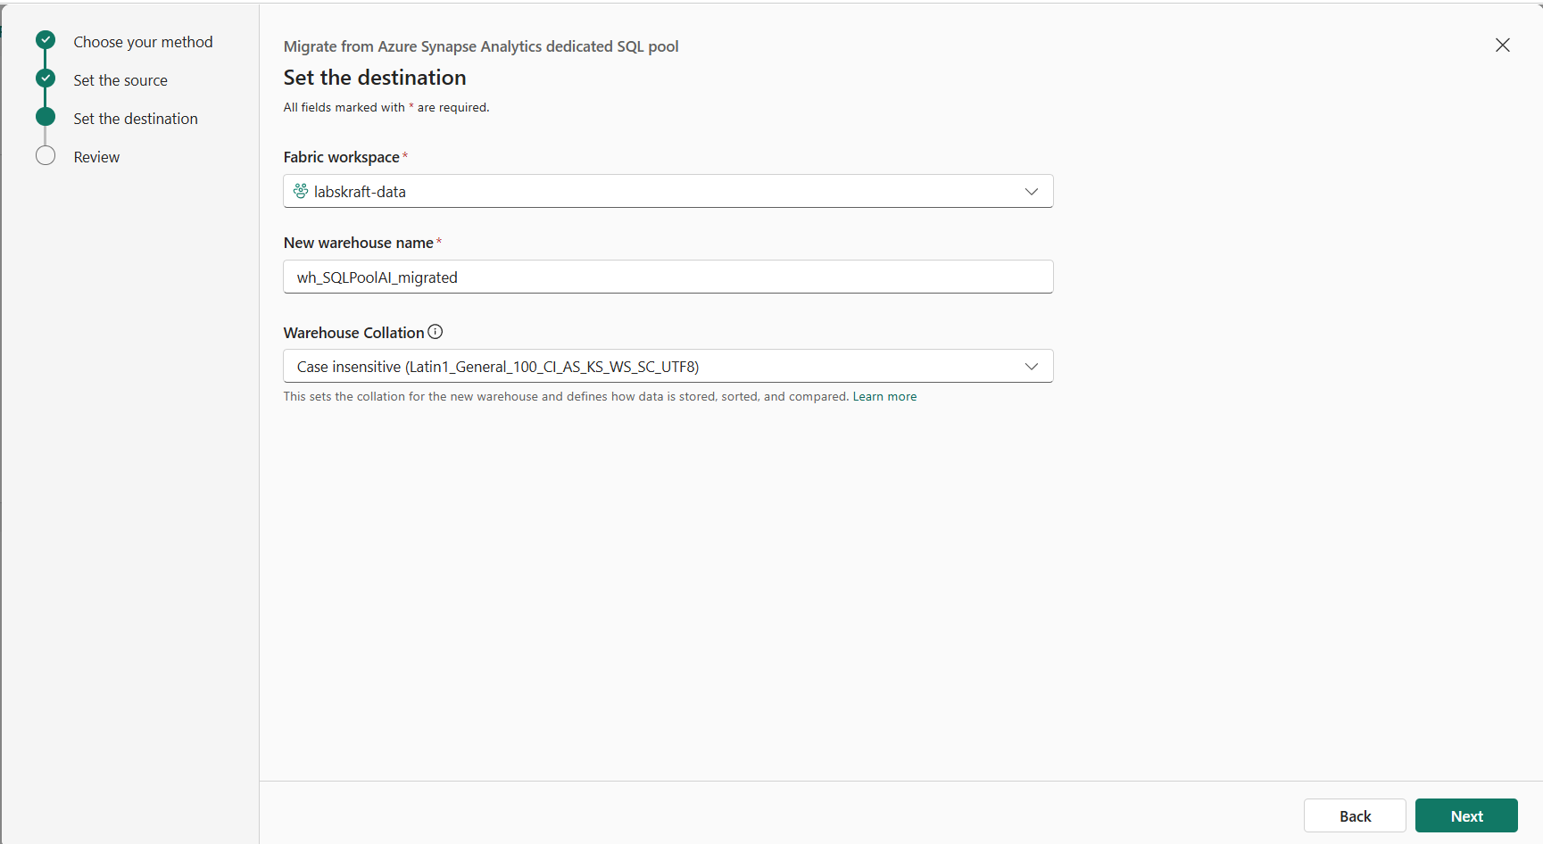
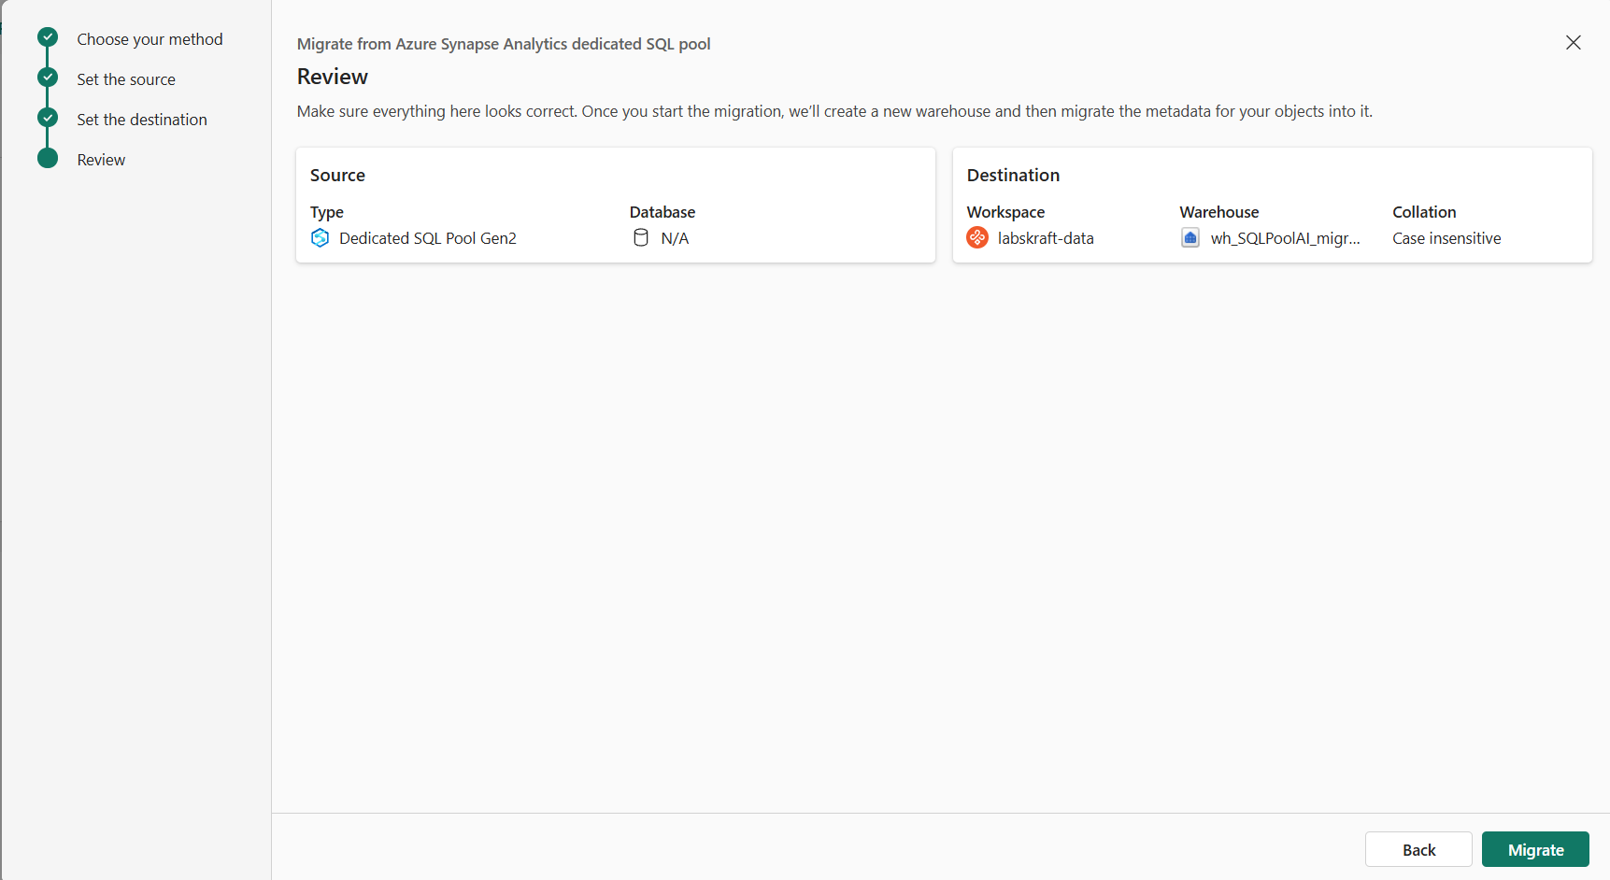
- Execute Scan / Assessment Only:
- Run the compatibility assessment scan against the SQLPoolAI database (sales schema).
- Important: Review the assessment report on-screen. Do NOT click "Execute Migration" or "Import Data".
Review the assessment before performing any migration operation.

STEP 10 — Review SQL Compatibility
Review the Migration Assistant results.
Identify:
- Supported objects
- Unsupported objects
- T-SQL compatibility issues
- Data-type differences
- Security dependencies
- Migration warnings
- Manual remediation requirements
Classify every significant object:
DIRECT MIGRATION
ADAPT
REFACTOR
REBUILD
RETAIN
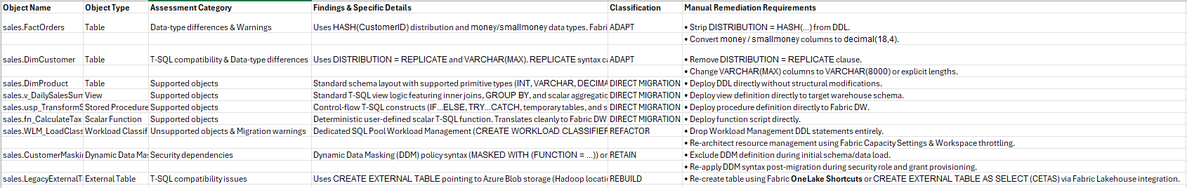
Save:
04_SQL_Compatibility_Matrix.xlsx
The current Fabric migration tooling provides a guided path for Synapse dedicated SQL pools and identifies objects requiring remediation. (Microsoft Learn)

PHASE 4 — SYNAPSE → FABRIC ARCHITECTURE MAPPING

STEP 11 — Map Each Workload
Create:
05_Synapse_to_Fabric_Mapping.xlsx
For each Synapse asset, define:
Synapse Asset | Fabric Target | Migration Method | Refactoring | Risk
Spark Pool | Fabric Spark | Assisted / Manual | Yes/No
Notebook | Fabric Notebook | Assisted / Refactor | Yes/No
Spark Job Definition | Fabric Spark Job Definition | Assisted / Manual | Yes/No
Lake Database | Fabric Lakehouse | Migration | Yes/No
Dedicated SQL Pool | Fabric Warehouse | Migration | Yes/No
Pipeline | Fabric Data Factory | Rebuild / Migration | Yes/No
ADLS Gen2 | OneLake / Shortcut / Migration | Architecture decision | Yes/No
Do not blindly use the example mappings.
Use the actual workload requirements discovered earlier.
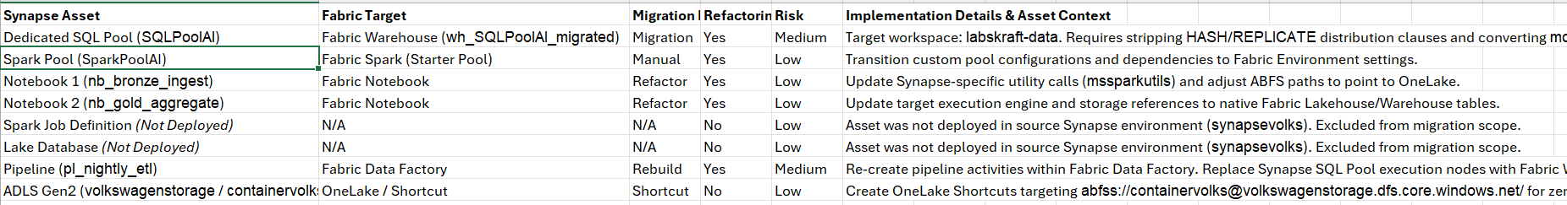

STEP 12 — Map Dependencies
For each workload, trace:
Source
↓
Synapse Asset
↓
Processing
↓
Storage
↓
Downstream Consumer
Document dependencies that must be migrated together.

Step 1: Trace the Raw Data Ingestion Path (Group A)
- Open Azure Synapse Studio (or your target Fabric Data Factory workspace).
- Open the pipeline pl_nightly_etl.
- Inspect the first execution block targeting nb_bronze_ingest:
  - Source Check: Confirm the notebook connects to external storage path abfss://containervolks@volkswagenstorage.dfs.core.windows.net/.
  - Storage Check: Confirm data lands in the raw/bronze storage layer.
  - Dependency Rule: Mark volkswagenstorage ADLS connection, pl_nightly_etl, and nb_bronze_ingest as Co-Migration Group A.
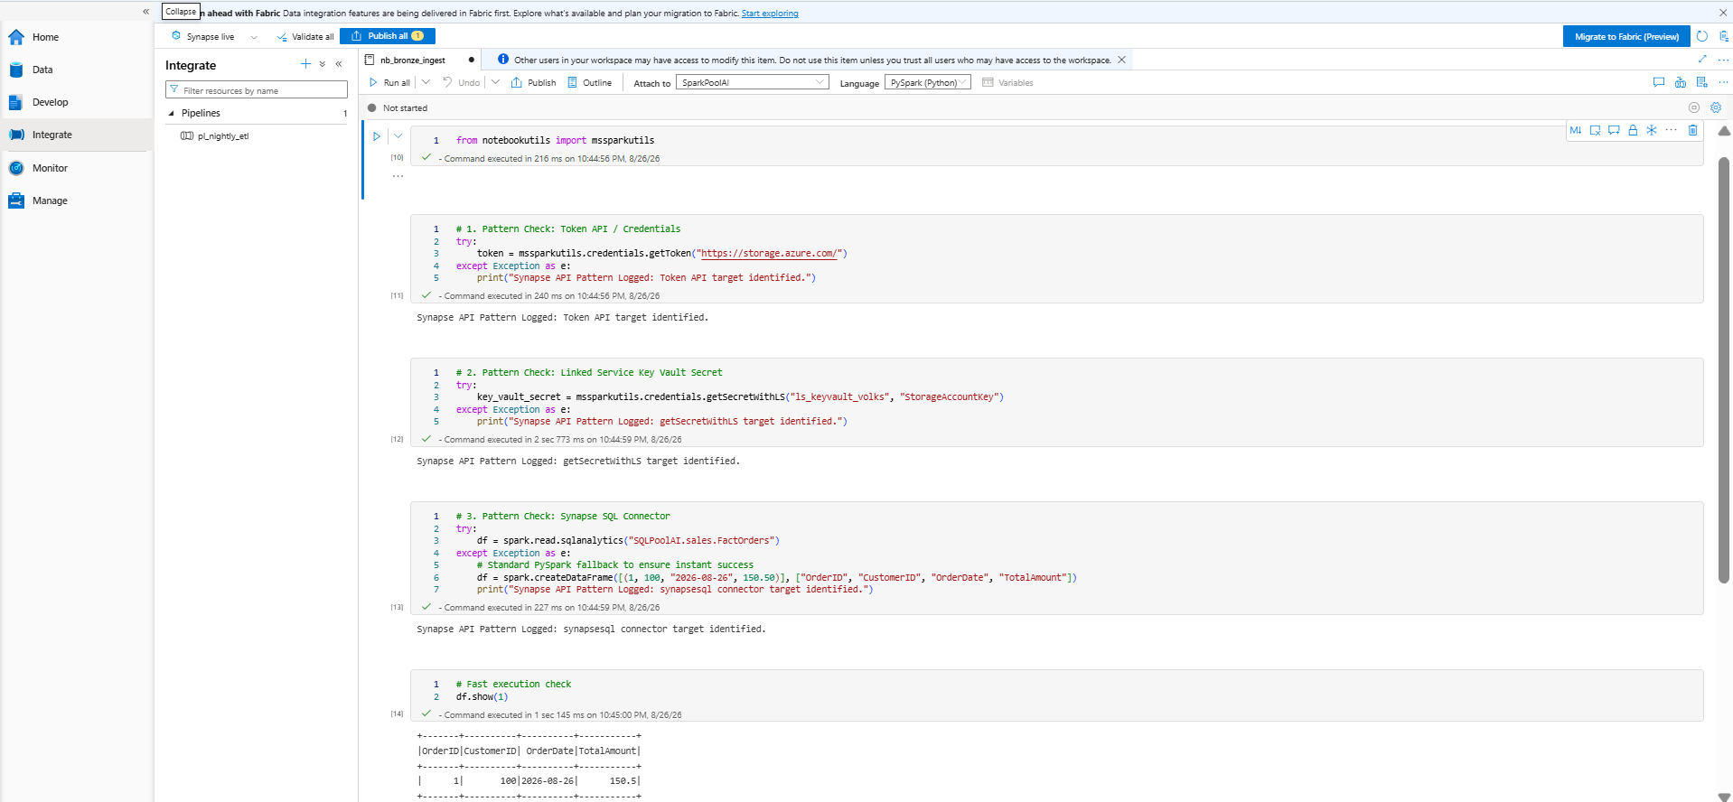

Step 2: Trace the Data Transformation & Aggregation Path (Group B)
- Inside pl_nightly_etl, select the downstream activity node that triggers nb_gold_aggregate.
- Inspect nb_gold_aggregate:
  - Processing Check: Verify PySpark reads from the raw/bronze layer and executes aggregations.
  - Target Check: Verify outputs target the gold layer within Fabric Lakehouse / Warehouse structures (wh_SQLPoolAI_migrated).
  - Dependency Rule: Mark nb_bronze_ingest outputs, nb_gold_aggregate, and target lake storage as Co-Migration Group B.
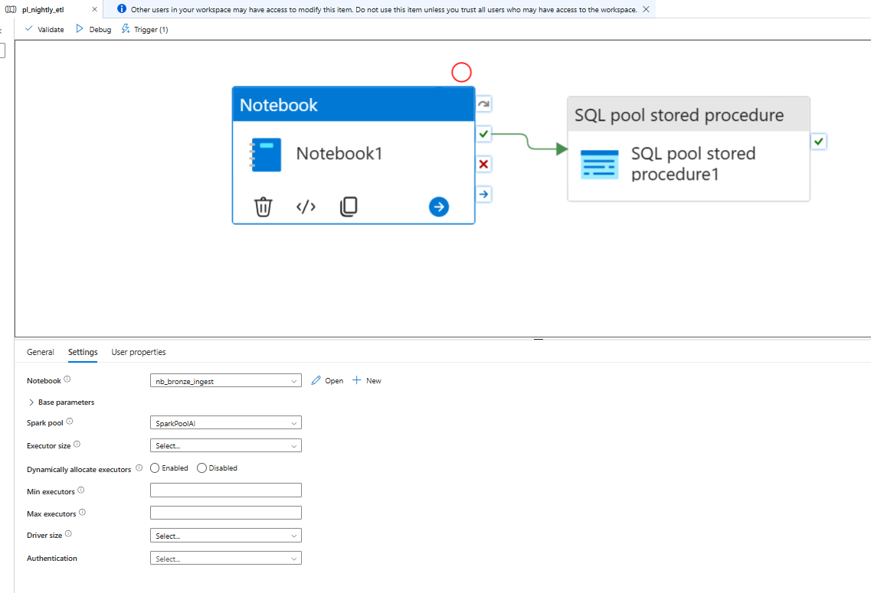

Step 3: Trace Relational SQL & Downstream Analytics (Group C)
- Check your SQL objects in SQLPoolAI:
  - Stored Procedure: Locate sales.usp_TransformSalesSummary.
  - Table Dependencies: Verify that sales.usp_TransformSalesSummary reads from sales.FactOrders, sales.DimCustomer, and sales.DimProduct.
  - Downstream Target: Confirm the final warehouse dataset feeds Power BI semantic models or enterprise dashboards.
  - Dependency Rule: Mark FactOrders, DimCustomer, DimProduct, sales.usp_TransformSalesSummary, and Power BI reporting models as Co-Migration Group C.
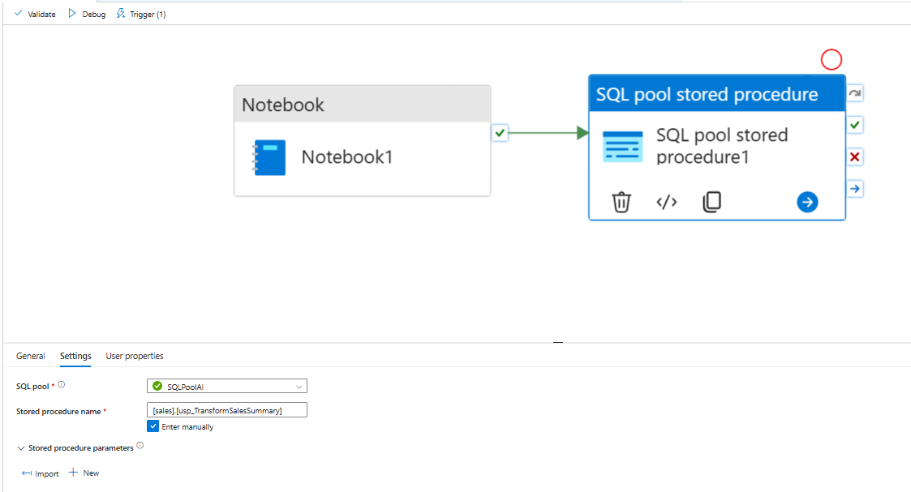
Example:
ADLS
↓
Linked Service
↓
Pipeline
↓
Notebook
↓
SQL / Lakehouse
↓
Power BI
Update:
05_Synapse_to_Fabric_Mapping.xlsx

PHASE 5 — MIGRATION PLAN

STEP 13 — Define Migration Strategy
For each workload select:
Lift-and-Shift
Phased Modernization
Parallel Run
Rebuild
Retain
Retire

Step 1: Validate Dedicated SQL Pool Strategy (SQLPoolAI)
- Open your DDL script for sales.FactOrders and sales.DimCustomer.
- Check for Legacy Constraints: Verify the presence of DISTRIBUTION = HASH(...), DISTRIBUTION = REPLICATE, or money data types.
- Confirm Strategy: Because Fabric Warehouse handles distribution automatically and requires standard decimal data types, confirm the strategy is Phased Modernization (requires DDL adaptation before deployment).

Step 2: Validate Spark & Notebook Strategies (sparkpool, nb_bronze_ingest, nb_gold_aggregate)
- Open nb_bronze_ingest and nb_gold_aggregate in Azure Synapse Studio.
- Check Code Compatibility: Verify that core PySpark code requires no rewrite, but utility functions (e.g., mssparkutils.credentials.getToken) and storage access paths need updating to OneLake.
- Confirm Strategy:
  - Spark Pool -> Lift-and-Shift (direct compute capacity mapping).
  - PySpark Notebooks -> Phased Modernization (logic stays, storage and utility APIs update).

Step 3: Validate Pipeline Strategy (pl_nightly_etl)
- Open pl_nightly_etl in Azure Synapse Studio.
- Check Automation Feasibility: Note that Azure Synapse pipelines cannot be automatically imported into Fabric Data Factory via a 1-click conversion button.
- Confirm Strategy: Confirm the strategy is Rebuild (manually re-creating activities in Fabric Data Factory canvas).

Step 4: Validate External Storage Strategy (volkswagenstorage)
- Inspect your storage account configuration (volkswagenstorage / containervolks).
- Check Data Virtualization Requirement: Confirm whether historical data will stay in ADLS Gen2 or be physically copied.
- Confirm Strategy: Confirm the strategy is Lift-and-Shift (Virtualize) via Fabric OneLake Shortcuts to maintain zero-copy data access.
Document the reason for the selection.
Create:
06_Migration_Strategy.xlsx
Microsoft's current migration guidance describes lift-and-shift, phased modernization and parallel-run approaches for Synapse Spark migrations. (Microsoft Learn)

STEP 14 — Create Migration Waves
Create:
07_Migration_Wave_Plan.xlsx
Assign workloads based on:
- dependencies
- business criticality
- compatibility
- complexity
- rollback requirements

Step 1: Check Wave Dependencies (Logical Order)
Verify that lower-numbered waves set up prerequisites for higher-numbered waves:
- Wave 0 (Foundation) must come first to set up the Fabric Workspace (labskraft-data) and shortcuts (volkswagenstorage).
- Wave 1 (Data Engineering) must come next so compute (sparkpool) and ingest notebooks (nb_bronze_ingest, nb_gold_aggregate) exist before loading data.
- Wave 2 (SQL / Analytics) comes third to build the warehouse structure (wh_SQLPoolAI_migrated) and stored procedures (sales.usp_TransformSalesSummary).
- Wave 3 (Orchestration) comes fourth so the pipeline (pl_nightly_etl) has existing notebooks and stored procedures to trigger.

Step 2: Check Asset Names (No Generic Placeholders)
Open 07_Migration_Wave_Plan.xlsx and scan the Target Workload / Asset column:
- Confirm that no placeholders like [Your_Notebook] or [Your_ADLS] remain.
- Confirm that your actual 6 assets are listed: volkswagenstorage, sparkpool, nb_bronze_ingest, nb_gold_aggregate, wh_SQLPoolAI_migrated, and pl_nightly_etl.

Step 3: Verify Rollback Strategies
Look at the Rollback & Fallback Strategy column for Waves 0 through 4:
- Confirm that Azure Synapse assets stay active as the fallback during early waves.
- Ensure you don't plan to turn off or delete Azure Synapse until Wave 5 (Cutover) after data verification completes.

Step 4: Confirm Un-deployed Assets Are Excluded
- Verify that Spark Job Definition and Lake Database are not listed in any of the wave rows, as they were never deployed in your source environment.

Step 5: Validate Data Reconciliation in Wave 4
- Confirm that Wave 4 (Parallel Run) explicitly mentions comparing output data (row counts and totals) between Synapse SQLPoolAI and Fabric wh_SQLPoolAI_migrated before signing off on final cutover.
Use a structure such as:
Wave 0 — Foundation
Wave 1 — Low Risk
Wave 2 — Data Engineering
Wave 3 — SQL / Analytics
Wave 4 — Critical Workloads
Wave 5 — Cutover
Replace the generic categories with the actual client workloads.

PHASE 6 — TARGET FABRIC ARCHITECTURE

STEP 15 — Create the Architecture Diagram
Create:
08_Synapse_to_Fabric_Architecture.drawio
Show the actual migration:
SYNAPSE
│
┌──────────────┼──────────────┐
│ │ │
Spark SQL Pipelines
│ │ │
└──────────────┼──────────────┘
│
MIGRATION
│
▼
MICROSOFT FABRIC
│
┌──────────────┼──────────────┐
│ │ │
Spark Warehouse Data Factory
│ │ │
└──────────────┼──────────────┘
│
OneLake
│
Semantic Layer
│
Power BI
Add:
- external data sources
- identity boundaries
- network boundaries
- dependencies
- migration waves
- target workloads

Step 1: Check Source vs. Target Asset Mappings
Ensure your diagram explicitly maps all 6 deployed items to their specific target components:
- Storage Layer: External ADLS Gen2 (volkswagenstorage / containervolks) -> Fabric OneLake Shortcut (Zero-copy virtualization).
- Ingestion Layer: Synapse Notebook nb_bronze_ingest -> Fabric Notebook (PySpark reading via OneLake shortcut).
- Aggregation Layer: Synapse Notebook nb_gold_aggregate -> Fabric Notebook (PySpark transformation to target tables).
- Warehouse Layer: Synapse Dedicated SQL Pool SQLPoolAI -> Fabric Warehouse (wh_SQLPoolAI_migrated with sales.usp_TransformSalesSummary).
- Orchestration Layer: Synapse Pipeline pl_nightly_etl -> Fabric Data Factory Pipeline.
- Analytics Layer: Transformed output views -> Power BI Semantic Model (Direct Lake / DirectQuery).

Step 2: Verify Architecture Annotations
Confirm that your .drawio diagram includes these mandatory structural boundaries:
- Migration Wave Badges:
  - Mark Wave 0 on OneLake Shortcuts.
  - Mark Wave 1 on Fabric Notebooks.
  - Mark Wave 2 on Fabric Warehouse.
  - Mark Wave 3 on Data Factory Pipelines.
- Identity & Security Boundaries: Show Entra ID (Azure AD) authentication connecting to Microsoft Fabric Workspace (labskraft-data) and Key Vault secrets for storage access.
- Data Dependency Flow: Draw directional arrows showing:
  - External ADLS -> OneLake Shortcut -> Fabric Notebooks -> Fabric Warehouse -> Power BI.
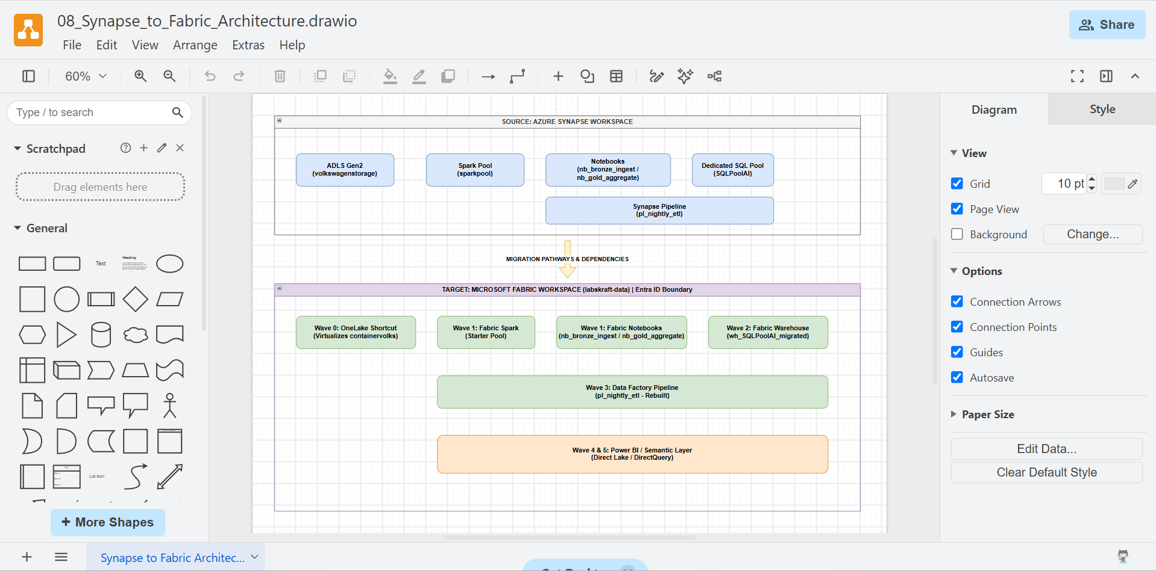

PHASE 7 — RISK & RUNBOOK

STEP 16 — Create Migration Risk Register
Create:
09_Migration_Risk_Register.xlsx
Capture:
Risk
Category
Probability
Impact
Risk Score
Mitigation
Owner
Trigger
Rollback Action
At minimum assess:
- Compatibility
- Data migration
- Security
- Networking
- Identity
- Performance
- Capacity
- Dependencies
- Cutover
- Rollback
Open 09_Migration_Risk_Register.xlsx and verify the following 3 checks:
- Required Columns Present: Ensure your sheet has all 9 required columns:
Risk | Category | Probability | Impact | Risk Score | Mitigation | Owner | Trigger | Rollback Action
- Mandatory Risk Categories Covered: Verify that risks are mapped across key categories:
  - Compatibility: Refactoring Synapse Dedicated SQL HASH distributions to Fabric Warehouse tables.
  - Data Migration / Networking: Bandwidth limits or connectivity issues when reading via OneLake shortcuts.
  - Pipeline / Dependencies: Failures in rebuilding Synapse pipelines natively inside Fabric Data Factory.
  - Cutover & Rollback: Reporting downtime during the final switchboard cutover from Synapse to Fabric.
- Scoring Logic: Confirm Risk Score is populated (e.g., $Probability \times Impact$ or qualitative scale like High/Medium/Low).

STEP 17 — Create Migration Runbook
Create:
10_Synapse_to_Fabric_Migration_Runbook.docx
Use:
1. Pre-Migration Validation
2. Dependency Validation
3. Fabric Readiness
4. Schema Migration
5. Data Migration
6. Code Refactoring
7. Pipeline Migration
8. Security Validation
9. Data Validation
10. Performance Validation
11. Business Validation
12. Parallel Run
13. Cutover
14. Post-Cutover Monitoring
15. Rollback
16. Synapse Decommissioning
For every activity include:
Action
Owner
Prerequisite
Expected Result
Validation
Rollback
Open 10_Synapse_to_Fabric_Migration_Runbook.docx and verify these 3 checks:
- Complete 16-Section Structure: Ensure your Word document contains all 16 numbered sections in exact order (from 1. Pre-Migration Validation down to 16. Synapse Decommissioning).
- 6 Required Activity Fields: Under every activity step, confirm these 6 specific parameters are defined:
  - Action: Exact operation performed.
  - Owner: Team role assigned (e.g., Lead Data Engineer, Cloud Architect).
  - Prerequisite: What must be completed prior to this step.
  - Expected Result: Successful operational state.
  - Validation: How success is checked (e.g., row count verification, pipeline execution status = Succeeded).
  - Rollback: Exact fallback procedure if the step fails.
- Asset Specificity: Confirm actions specifically name your workspace assets (volkswagenstorage, sparkpool, nb_bronze_ingest, nb_gold_aggregate, SQLPoolAI, pl_nightly_etl).

FINAL VALIDATION

STEP 18 — Complete Migration Readiness Assessment
Review every asset in the inventory.
Every workload must have:
Fabric Target
Migration Method
Compatibility Status
Migration Wave
Dependencies
Risk
Validation Method
Rollback Strategy
Assign the final status:
READY
REFACTOR
REBUILD
RETAIN
RETIRE
BLOCKED

Final Deliverables
01_Synapse_Estate_Inventory.xlsx
02_Spark_Migration_Assessment.xlsx
03_Spark_Compatibility_Matrix.xlsx
04_SQL_Compatibility_Matrix.xlsx
05_Synapse_to_Fabric_Mapping.xlsx
06_Migration_Strategy.xlsx
07_Migration_Wave_Plan.xlsx
08_Synapse_to_Fabric_Architecture.drawio
09_Migration_Risk_Register.xlsx
10_Synapse_to_Fabric_Migration_Runbook.docx
